SUSTAINABLE PRODUCT DESIGN CHALLENGE
Redesign Everyday: Make It Greener!

Background
- As Australia transitions towards a more sustainable and technologically advanced future, it is essential to equip the next generation with the skills and mindset needed to lead this transformation. Despite growing awareness of environmental challenges, many young students lack opportunities to apply their creativity and problem-solving abilities to real-world sustainability issues. The Sustainable Product Design Challenge was created to bridge this gap — by connecting high school students with emerging technologies such as 3D printing, digital design, and materials innovation, and encouraging them to rethink how everyday products can be made greener. Through national collaboration with universities, industry mentors, and local governments, this program aims to cultivate future-ready talents while promoting environmental responsibility and hands-on innovation.
Vision:
To inspire and equip Australian secondary students with future-ready advanced manufacturing skills through project-based learning and national industry collaboration.
Mission:
To cultivate interest and proficiency in design, digital fabrication, materials innovation, robotics, and sustainable manufacturing by solving authentic, industry-relevant problems, with the opportunity to showcase solutions at a national platform.
To have fun together.
Join the Sustainable Product Design Challenge and reimagine an everyday object to make it more eco-friendly, using science, creativity, and 3D printing.
WHO CAN JOIN?
Year 9–11 secondary students from all Australian schools.
WHAT TO DO?
- Identify a real-world object or usage scenario that creates waste or consumes resources.
- Redesign it with a sustainable twist.
- Model it using CAD software (e.g., Fusion360; TinkerCAD).
- Submit your CAD file, a one-page product brief, and a 1-minute demo video.
What You Will Learn
- Design thinking & sustainability principles
- 3D modeling (CAD tools like TinkerCAD or Fusion360)
- Additive manufacturing and rapid prototyping
- Presentation and pitching skills
- Industry collaboration and real-world innovation

KEY DATES
- Registration Opens: August 20
- CAD & Innovation Workshop: August 25 (4 hour)
- Offline 3D printing tutorial workshop: September 20 (4 hour)
- Final Submission Deadline: October 10
- Live Showcase & Grand Final Ceremony at ICNASA 2025 international conference: November 13
Judge panel
- Jagdish
- Hala
- Sandra
- Melbourne city official
- Scan&Print3D expert
Mentor

PRIZES & EXHIBITION
- All participants will receive a certificate for completion of the challenge and recorded in the database
- Top projects will be 3D printed and showcased during the International Conference on Nanomaterial and Atomaterial Science and Applications (ICNASA) in Melbourne.
- Awards include Best Green Innovation, Best Engineering Design, Business Potential Award, and more.
- All challenge solution pieces will be registered into solution database and made available for industry. If being selected by industry, commercial arrangement can be made
- Attended students will have the priority to be selected by local industry for volunteer or employment opportunities.

Organiser: ANMFC and RMIT
Sponsors:
- ATSE
- Centre for Atomaterials and Nanomanufacturing, RMIT
- Melbourne city
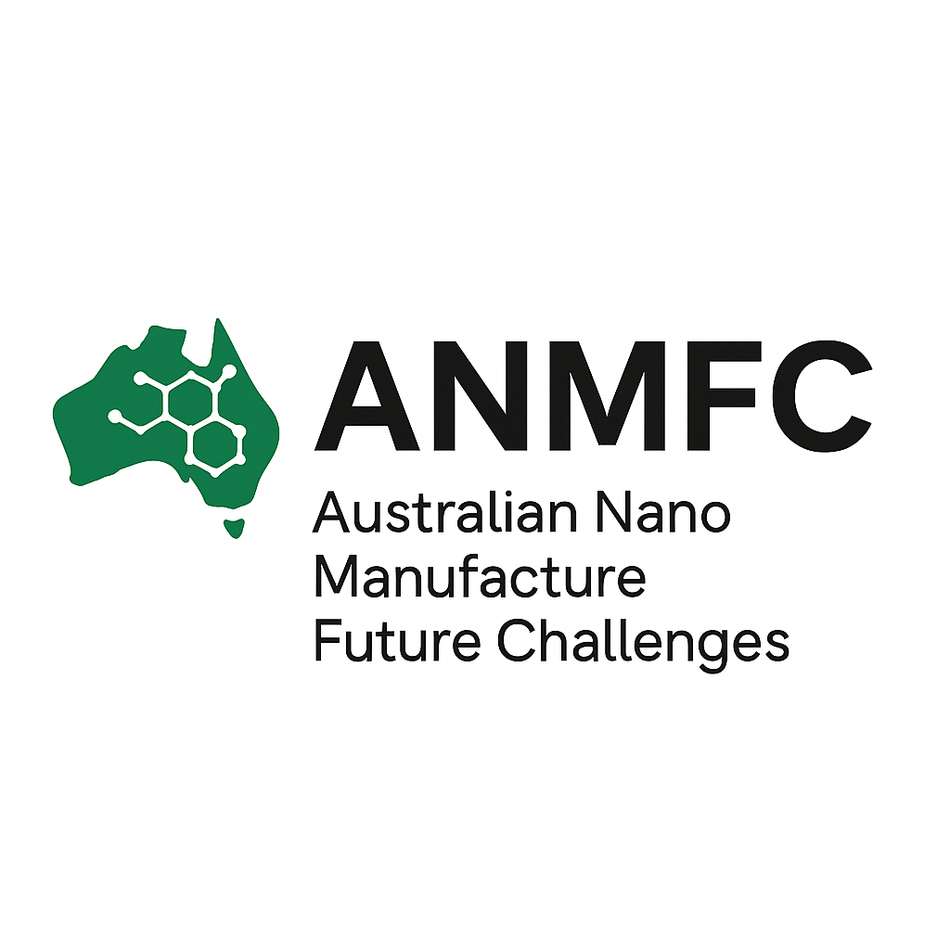
- Scan&Print3D
- Innofocus
- ERGENG PTY LTD

SUBMIT YOUR WORK AT:
www.anmfc.com.au
Organized by the CAN Centre, RMIT University
Supported by Scan&Print3D and industry mentors

